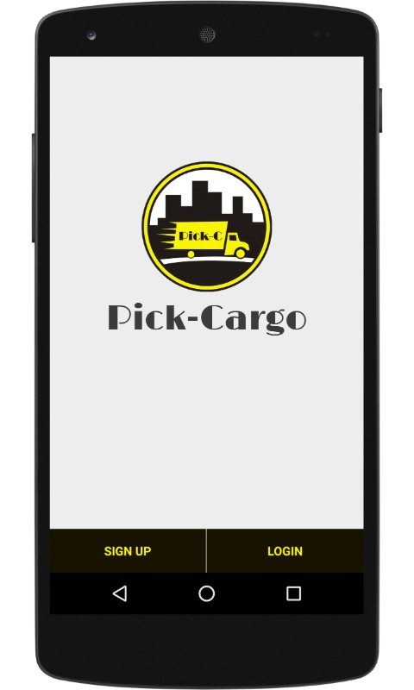  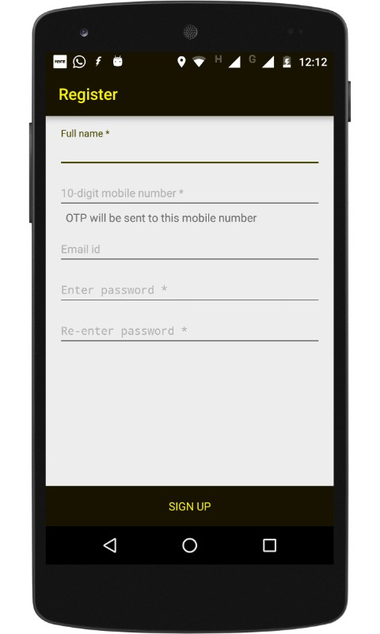  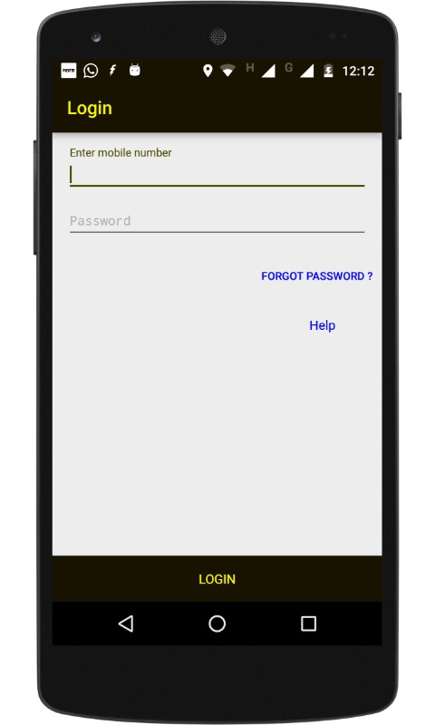  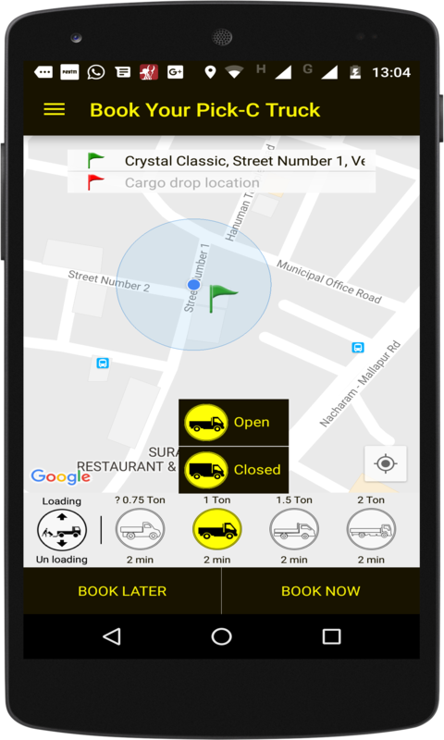  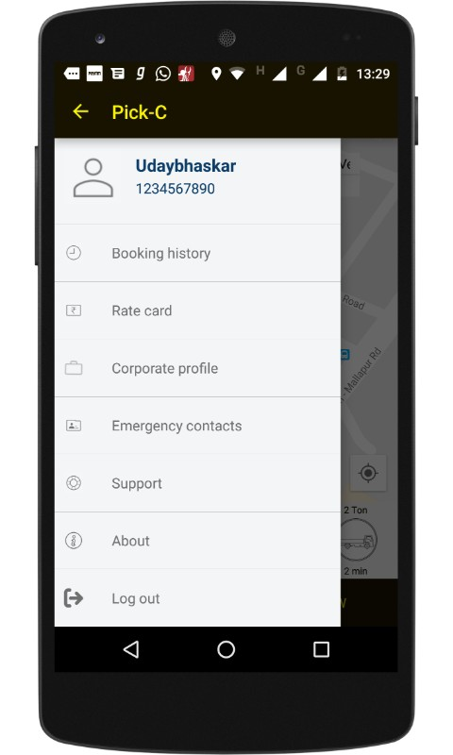  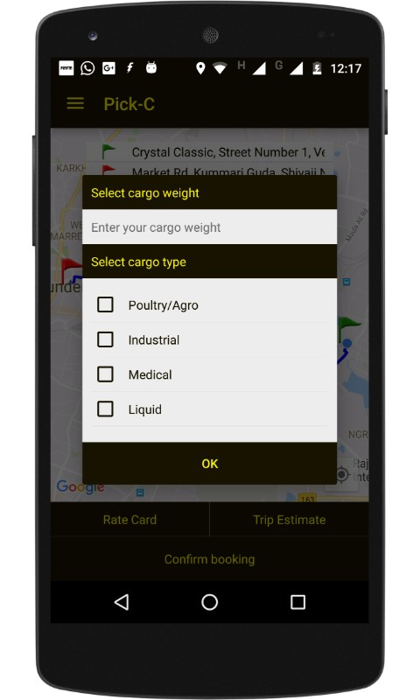  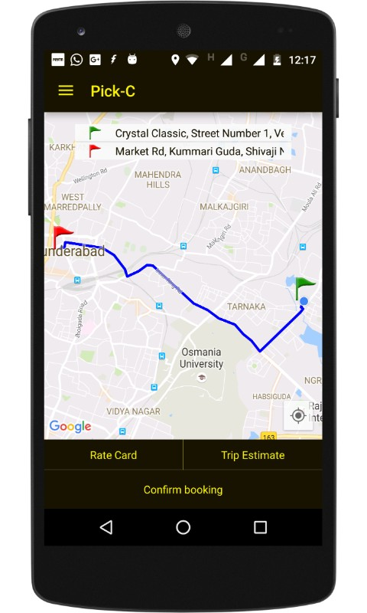  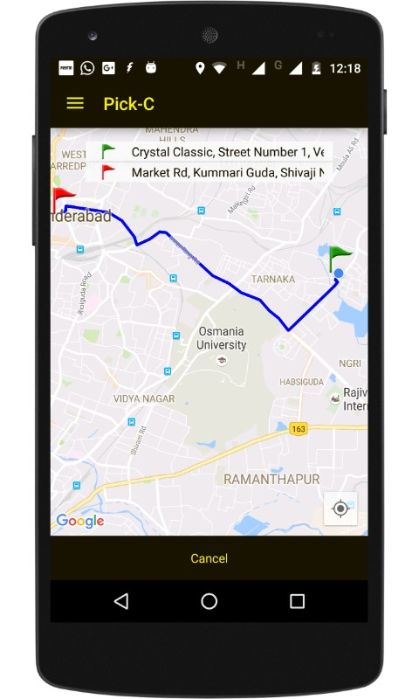  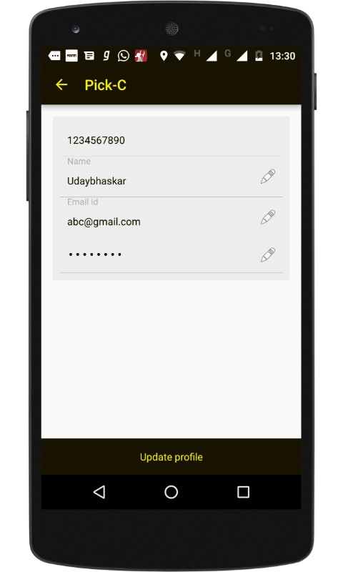  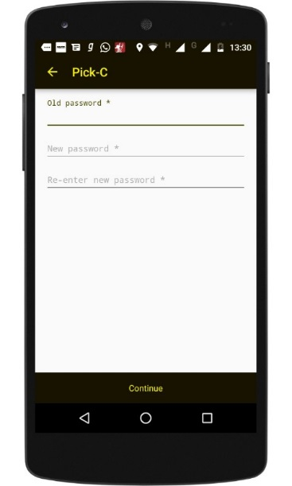  S No | Screen Shots | API Info
1 |  | - To verify token  (api/master/customer/list)  Method: GET  Response Payload:  [  {  "MobileNo": "1234561234",  "Name": "vjbggz",  "EmailID": ""  },  {  "MobileNo": "1234567890",  "Name": "Udaybhaskar",  "EmailID": "abc@gmail.com"  },  {  "MobileNo": "1234567891",  "Name": "123",  "EmailID": ""  },  {  "MobileNo": "1234567899",  "Name": "uday",  "EmailID": "uday@gmail.com"  },  {  "MobileNo": "8019230706",  "Name": "Babu Arigela",  "EmailID": "arigelavijay@ymail.com"  },  {  "MobileNo": "8977538684",  "Name": "Udaybhaskar",  "EmailID": "udayfionics@gmail.com"  },  {  "MobileNo": "8977538689",  "Name": "Uday",  "EmailID": "uday2@gmail.com"  },  {  "MobileNo": "9848853542",  "Name": "sridhar",  "EmailID": ""  },  {  "MobileNo": "9885217825",  "Name": "sudarshan",  "EmailID": "ragsarma@gmail.com"  },  {  "MobileNo": "9963849994",  "Name": "sridhar",  "EmailID": "paruchuri.sridhar@gmail.com"  },  {  "MobileNo": "9963849999",  "Name": "sridh",  "EmailID": ""  },  {  "MobileNo": "9966586830",  "Name": "Vijaya Babu Arigela",  "EmailID": "arigelavijayababu@gmail.com"  }  ]
2 |  | - VERIFY_MOBILE_NO_API_CALL  (api/master/customer/check/<mobileNO>)  Method: GET  Response: bool  - CUSTOMER_SAVE_API_CALL  (api/master/customer/save)  Method: POST  Payload:  {  "MobileNo": "8019230706",  "Name": "Babu Arigela",  "EmailID": "arigelavijay@ymail.com"  }  Response : string  Ex: SAVED SUCSSFULLY
- LOG_IN_API_CALL
(api/master/customer/login)
Method: POST
Payload: {
MobileNo": "8019230706",
Password: “vijay”
}

Response: {
Token: ‘11E2FC2F-8D2D-4127-925B-FFEDC0E2DB5F’ }

- CUSTOMER_INFO_API_CALL
(api/master/customer/<mobileNo>)
Method: GET
Response: {
"MobileNo": "8019230706",
"Name": "Babu Arigela",
"EmailID": "arigelavijay@ymail.com"
}

- Help Url
(http://ragsarma-001-site6.htempurl.com/Help/menu)
5 |  | - VEHICLE_GROUP_LIST  (api/master/vehiclegroup/list)  Method: GET  Response: [  {  "LookupID": 1000,  "LookupCode": "750",  "LookupDescription": "? 0.75 Ton",  "LookupCategory": "VehicleGroup"  },  {  "LookupID": 1001,  "LookupCode": "1T",  "LookupDescription": "1 Ton",  "LookupCategory": "VehicleGroup"  },  {  "LookupID": 1002,  "LookupCode": "1.5T",  "LookupDescription": "1.5 Ton",  "LookupCategory": "VehicleGroup"  },  {  "LookupID": 1003,  "LookupCode": "2T",  "LookupDescription": "2 Ton",  "LookupCategory": "VehicleGroup"  }  ]  - VEHICLE_TYPE_LIST  (api/master/vehicletype/list)  Method: GET  Response: [  {  "LookupID": 1300,  "LookupCode": "Open",  "LookupDescription": "Open",  "LookupCategory": "VehicleType"  },  {  "LookupID": 1301,  "LookupCode": "Closed",  "LookupDescription": "Closed",  "LookupCategory": "VehicleType"  }  ]  - RATE_CARD_LIST  (api/master/ratecard/list)  Method: GET  Response: [  {  "Category": 1003,  "VehicleCategoryDescription": "2 Ton",  "VehicleType": 1301,  "RateType": 1350,  "VehicleTypeDescription": "",  "RateTypeDescription": "",  "BaseFare": 400,  "BaseKM": 3,  "DistanceFare": 37,  "WaitingFare": 100,  "RideTimeFare": 2,  "CancellationFee": 0,  "DriverAssistance": 0,  "OverNightCharges": 0  },  {  "Category": 1003,  "VehicleCategoryDescription": "2 Ton",  "VehicleType": 1301,  "RateType": 1351,  "VehicleTypeDescription": "",  "RateTypeDescription": "",  "BaseFare": 3450,  "BaseKM": 150,  "DistanceFare": 26,  "WaitingFare": 100,  "RideTimeFare": 0,  "CancellationFee": 0,  "DriverAssistance": 0,  "OverNightCharges": 0  }  ]
6 |  | - CUSTOMER_INFO_API_CALL  (api/master/customer/<mobileNo>) same as above  - BOOKING_HISTORY_LIST_API_CALL_BASED_ON_MOBILE_NO  (api/operation/booking/list/<mobileNo>)  Method: GET  Response: [  {  "BookingNo": "BK161000001",  "BookingDate": "2016-10-12T05:52:15.987",  "CustomerID": "8019230706",  "RequiredDate": "2016-10-12T18:21:00",  "LocationFrom": "Kukatpally Housing Board Road, LIG, Hyderabad, Telangana, India",  "LocationTo": "Koti Main Road, Kachiguda, Hyderabad, Telangana, India",  "CargoDescription": "",  "VehicleType": 1300,  "VehicleGroup": 1001,  "Remarks": "",  "IsConfirm": true,  "ConfirmDate": "2016-11-01T16:42:12.453",  "DriverID": "DR161000001",  "VehicleNo": "APBZ053250",  "IsCancel": false,  "CancelTime": "0001-01-01T00:00:00",  "CancelRemarks": "",  "IsComplete": false,  "CompleteTime": "0001-01-01T00:00:00",  "PayLoad": "",  "CargoType": "",  "Latitude": 17.4726541,  "Longitude": 78.3875686  }  ]  - RateCard URL  (http://ragsarma-001-site6.htempurl.com/ratecard/mobile)  - Suppor URL  (http://ragsarma-001-site6.htempurl.com/Help/menu)  - LOG_OUT_API_CALL  (api/master/customer/logout)  Method: GET  Response: USER LOGGEDOUT SUCCESSFULLY
7 |  | - CARGO_TYPE_LIST_API_CALL  (api/master/cargotype/list)  Method: GET  [  {  "LookupID": 1340,  "LookupCode": "Poultry",  "LookupDescription": "Poultry/Agro",  "LookupCategory": "CargoType"  },  {  "LookupID": 1341,  "LookupCode": "Industrial",  "LookupDescription": "Industrial",  "LookupCategory": "CargoType"  }  ]
8 |  | - BOOKING_API_CALL  (api/operation/booking/save)  Method: POST  Response: {  "BookingNo": "BK160800001",  "BookingDate": "2016-08-23T00:00:00",  "CustomerID": "1234567890",  "RequiredDate": "2016-08-23T00:00:00",  "LocationFrom": "lat: 17.5125113, long: 78.3522278",  "LocationTo": "Miyapur - Janapriya West City Rd, Mahaboobpet Maqta, Miyapur, Hyderabad, Telangana 500049, India, ",  "CargoDescription": "Cargo Desc 750 Kg",  "VehicleType": 1300,  "VehicleGroup": 0,  "Remarks": "Remarks will be here",  "IsConfirm": true,  "ConfirmDate": "2016-11-03T13:47:52.61",  "DriverID": "DR161000001",  "VehicleNo": "VH0001",  "IsCancel": false,  "CancelTime": "0001-01-01T00:00:00",  "CancelRemarks": "",  "IsComplete": false,  "CompleteTime": "0001-01-01T00:00:00",  "PayLoad": "",  "CargoType": "",  "Latitude": 0,  "Longitude": 0  }
9 |  | - BOOKING_CANCEL_API_CALL  (api/operation/booking/<bookingNo>)  Method: GET  Response: {  "BookingNo": "BK160800001",  "BookingDate": "2016-08-23T00:00:00",  "CustomerID": "1234567890",  "RequiredDate": "2016-08-23T00:00:00",  "LocationFrom": "lat: 17.5125113, long: 78.3522278",  "LocationTo": "Miyapur - Janapriya West City Rd, Mahaboobpet Maqta, Miyapur, Hyderabad, Telangana 500049, India, ",  "CargoDescription": "Cargo Desc 750 Kg",  "VehicleType": 1300,  "VehicleGroup": 0,  "Remarks": "Remarks will be here",  "IsConfirm": true,  "ConfirmDate": "2016-11-03T13:47:52.61",  "DriverID": "DR161000001",  "VehicleNo": "VH0001",  "IsCancel": false,  "CancelTime": "0001-01-01T00:00:00",  "CancelRemarks": "",  "IsComplete": false,  "CompleteTime": "0001-01-01T00:00:00",  "PayLoad": "",  "CargoType": "",  "Latitude": 0,  "Longitude": 0  }  - BOOKING_INFO_IS_CONFIRM_API_CALL_BASED_ON_BOOKING_NO  (api/operation/booking/isconfirm/<bookingNo>)  Method: GET  Response:  {  isConfirm: true,  driverId: '',  vehicleNo: '',  driverName: '',  driverImage: '',  latitude: '',  longitude: ''  }
10 |  | - CUSTOMER_INFO_API_CALL  (api/master/customer/<mobileNo>)  same as above  - UPDATE_USER_PROFILE_API_CALL  (api/master/customer/<mobileNo>)  Method: GET  Response: {  "isConfirm": true,  "driverId": "DR161000001",  "vehicleNo": "APBZ053250",  "driverName": "VIJAY",  "driverImage": "",  "latitude": "17.5013877000",  "longitude": "78.3603559000"  }
11 |  | - UPDATE_PROFILE_PASSWORD_API_CALL  (api/master/customer/changepassword/<mobileNo>)  Method: POST  Response: {  MobileNo: '9966586830',  Password: 'vijay',  NewPassword: 'babu'  }

Note: For every api call expect for login, two headers to be there
- AUTH_TOKEN
- MOBILENO
After login you will have token as response.

